Lessons of the Real Resistance
Choices might appear when people least expect them.
APRIL 2, 2019
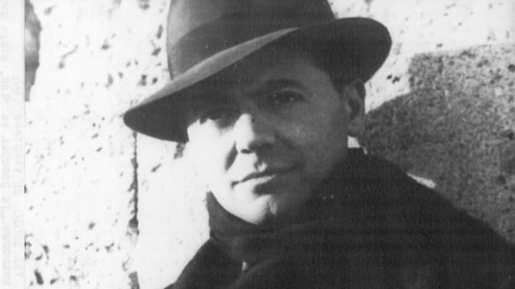
The French resistance leader Jean MoulinAP

It is one thing to read about a tortured man in a cell. It is another to stand in that cell, even if the events happened long ago, and even if there is no stench of unwashed bodies or overflowing toilet bucket, no crowding of half a dozen in a room that would be cramped for one, no moans of men and women recovering from the torments of the day and anticipating those of tomorrow.
I was in Montluc prison in Lyon with some 45 students and faculty studying occupation, collaboration, and resistance in France from 1940 to 1945. The cell had been occupied by Marc Bloch, the great medievalist and one of the founders of the Annales school of history, which looks at the long sweep of the past and the larger forces that shape our world. A veteran of the First World War, he had served as a staff officer in the second, and after France’s shattering six-week defeat in 1940 wrote a reflection, Strange Defeat, that remains a powerful analysis of the tragedy. He continued to write and teach, joined the Resistance, and was captured.
Bloch was an archetype of the civilized man in barbaric times, the intellectual who sought to understand even as the patriot in him insisted on resisting. One of his Resistance companions wrote, “It was bad enough to know that he had been beaten, tortured; that the body of this slim man on which distinction sat with so natural an air, that this refined, moderate-minded proud intellectual had been plunged into an ice-cold bath, and then, choking and shivering, had been struck, beaten, and outraged … We could not, literally could not, bear to contemplate the picture which this news conjured up …”

When the end came, a trembling 16-year-old standing next to Bloch before the wall asked, “Will it hurt?” He took the lad by the arm and said, “No my boy: It won’t hurt at all.” And then the shots rang out.
The word resistance connoted many things in France during the dark years. It might involve dramatic ambushes or sabotage; it might mean working a primitive mimeograph machine to produce an underground newspaper; it could simply mean tapping out dot-dot-dot-dash—V in Morse code, for victory—with a spoon in a school cafeteria. It occurred in different times and ways. People joined and people dropped out. They operated alone or under the direction of charismatic leaders or the Communist Party. They squabbled over turf and strategy. Some even betrayed one another for personal or political reasons. Jean Moulin, appointed by the exiled Charles de Gaulle to coordinate the Resistance, was probably turned in by one of his top subordinates. He died after weeks of torture, but did not break.
For most Frenchmen, the course that was indicated was better covered by the word accommodation—accommodation to the realities of earning a living, encountering Germans on patrol or in the metro, getting permits and certificates to conduct daily life. Accommodation was understandable and reasonable. Most people were not, because so few ever are, heroes.
The collaborators, on the other hand, were a murky bunch. There were those who believed that patriotic duty required staying in their jobs—and indeed, most French officials and soldiers initially had little use for de Gaulle’s handful of London-based exiles. There were those who started as one thing and became another. Perhaps the most interesting were the bureaucrats who began by thinking that they were shielding France from the worst, and found themselves rounding up foreign Jews in anticipation of their German masters’ orders.
This was a starker world than ours, but the rationalizations of those who seek to get along with power, to acquire or retain it, even as their integrity slips away, do not change. There is always the ultimate excuse: Someone worse will follow you. Some of the sins were venial; some were vile. The excuses were perhaps greater, too. France was at the mercy of occupiers who literally had no limits in what they were willing to do.
There were, finally, the monsters. The thugs and sadists of the Vichy milice, for example, many of whom were killed during the “savage purification” that France experienced in 1945. There was Klaus Barbie, the butcher of Lyon, who traveled hours from his headquarters to personally conduct the arrest and interrogation of several dozen Jewish children hidden in the beautiful Savoy hill country. Their teachers were shot. The children were sent to Auschwitz. Barbie liked doing those things in person, because he preferred to torture members of the Resistance himself—or rather, to begin with their family members standing before them. Or perhaps starting on the family members first.
Returning from the last of these sites, some of the Jewish students and faculty (with one non-Jewish German colleague, one of the more profoundly moral people I know) realized that it was the festival of Purim. And so, after a draining day contemplating sadism, murder, and the pictures of happy children who could not know that in a short time they would be rolling on transports to the East, we sat down to read, as Jews do, the Book of Esther.
That book, which does not mention God, tells the story of a wicked vizier to the Persian king, who seeks to annihilate the Jews of the empire for one reason only: The Jew Mordecai, alone of the members of the court, refuses to bow down to him. The plot is eventually foiled when Queen Esther, Mordecai’s niece, who has kept her ethnicity and faith to herself, pleads for her people to King Ahasuerus. But it requires Mordecai appealing to her to do this, despite her fearful reminder that those who come to the King unbidden suffer death, and she has not been summoned for a month.
Esther’s uncle is stern: “Do not imagine to escape of all the Jews in the house of the king. For if you indeed remain silent, relief and rescue will come to the Jews from elsewhere, and you and your father’s house will perish. And who knows whether it is for just a time like this you have attained royalty?” The queen accepts the rebuke, and moves to act, only asking for her community’s prayers. “And so, I shall come to the king not according to the rule, and if I perish, I perish.”
This, too, was resistance. Mordecai’s resistance was the instinctive reaction of the faithful, who simply would not offer to a man the obeisances that belong to God. Esther’s, conversely, was the conscious resistance of a reluctant and troubled individual confronted by a sudden awful choice, who accepted a higher duty. Both kinds of resistance—the instinctive and the considered—have their place in the moral-political universe.
The word resistance is much overused in American politics these days, because it refers to a kind of opposition that does not threaten to bring with it dreadful consequences. A visit to Montluc, on the other hand, or a reading of the Book of Esther, brings home the reality that such choices might appear when we least expect them, and who knows whether any of us would have the courage of Marc Bloch? We cannot, of course, answer that question, but we can, if we will it, learn enough to pay homage to, and be inspired by, those who do.
ELIOT A. COHEN is a contributing writer at The Atlantic and dean of The Johns Hopkins University School of Advanced International Studies. From 2007 to 2009, he was the Counselor of the Department of State. He is the author most recently of The Big Stick: The Limits of Soft Power and the Necessity of Military Force. Source: https://www.theatlantic.com/ideas/archive/2019/04/todays-resistance-movement-could-learn-history/586261/

